BRAC University (Department of Computer Science and Engineering)

CSE 221 (Algorithms) for Summer 2025 Semester

Makeup of Quiz 1
Student ID:
Section: Full Marks: 20

Name: Duration: 20 minutes

- Write the time complexity of the following code snippet. Show your works/reasoning. (3*2=6 marks)

a) for (i =1; i*i <= n; i++)
for (j =1; j<= n; j++)
sum += i + j

b) worstCase(n):
for (int i = 0; i < n; i = i * 3)
for (int j = n; j >= 1; j = j / 5)
for (int k = 1; k <= n; k = k + 5)
sum += i + j + k

- For each of these pairs of functions (f(n), g(n)), identify whether f(n) = O(g(n)) or f(n) = ꭥ(g(n)). Write “True” or “False” for the two options in each case in the question paper. 10 marks

f(n) | g(n) | f(n) = O(g(n)) | f(n) = ꭥ(g(n))
log n² | log n + 5
( $\sqrt[3]{n}$ + n ) (30$\sqrt{n}$) | $\sqrt{n}$
n³ | n² log n^{n}
3^{n}.n⁴ | 2^{n}
log log n | log n

- Consider an 2D sorted array with m rows and n columns. Your task is to check if an item is in the 2D array or not. Now, write an efficient pseudocode or program with logarithmic time complexity to find the row and column of an item in this 2D array. If the item is not in the 2D array the program should print -1. To help you solve this problem, a python implementation of searching in 1D array is given which you can use in your code. You can call this function anywhere in your program
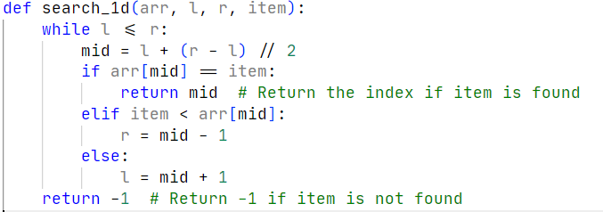
4

